[Chinmaynandkishor_mathakari@student.uml.edu](mailto:Chinmaynandkishor_mathakari@student.uml.edu)

[Utpal_patel@student.uml.edu](mailto:Utpal_patel@student.uml.edu)

**Table of Content**

|  |  |  |
| --- | --- | --- |
| **Sr. No** | **Index** | **Page** |
| **Chapter 1** | **Abstract** | 02 |
| **Chapter 2** | **Work** |  |
| 2.1 | Project work | 03 |
| 2.2 | Project workflow | 04 |
| 2.3 | Division of work | 05 |
| 2.4 | Technologies | 06 |
| **Chapter 3** | **Installation Process** |  |
| 3.1 | Build/Installation/launch Instruction | 07 |
| 3.2 | Use of Software | 08 |
| **Chapter 4** | **Limitations** | 09 |
|  |  |  |
| **Chapter 5** | **Future Work** | 09 |
| **Chapter 6** | **References** | 10 |

**CHAPTER-1**

**Abstract:**

Our web application recruiter can use to design an exam and evaluate the candidates' Knowledge and critical thinking abilities. A recruiter can create an account here, and that account will be verified via email through a web page link. On that link, the recruiter must provide information about himself/herself as well as the company. Following the creation of the profile, the recruiter can create assessments in which he or she can include multiple choice, coding, video, and essay-type questions. The correct answer will be pre-determined by the recruiter in this case. We are also planning to connect with an online code editor for coding questions. After successfully creating an assessment, the recruiter will be prompted to enter the names of candidates and their email addresses for whom the recruiter wishes to conduct an assessment. The web application will now send a web page link to the candidates' email addresses so that they can participate in the

assessment. At the start of the assessment, the candidate’s name, candidate ID, and live image will be requested. After passing the exam, the candidate's performance will be saved in the database so that the employer can see the result.

We plan to take images from the video every 10 seconds so that the recruiter can create a video and keep track of candidates. And very few websites provide all one package to assess candidates on different abilities.

# Problem Statement:

As a result of competition in the market, many businesses need a platform to hire talent. Our web application will help them. With the help of our website, business or recruiters can hire talent and assess them by developing their own questions on different topics.

# CHAPTER-2: WORK

* 1. **Project work**

Our project is divided into two sections: recruiter and applicant. The recruiter will sign up for the web app and be prompted to provide information about the firm and other details. After logging into the system, the recruiter will be forwarded to the homepage, where he or she may develop new assessments. This form primarily asks for the assessment's title and job position, after which the recruiter can add the candidate's name and email- mail address of them he or she would like to evaluate. The recruiter will next create the questions for the created test, which will be separated among multiple choice questions, coding questions, essay writing questions, video questions, and multiple select questions.

# Workflow:

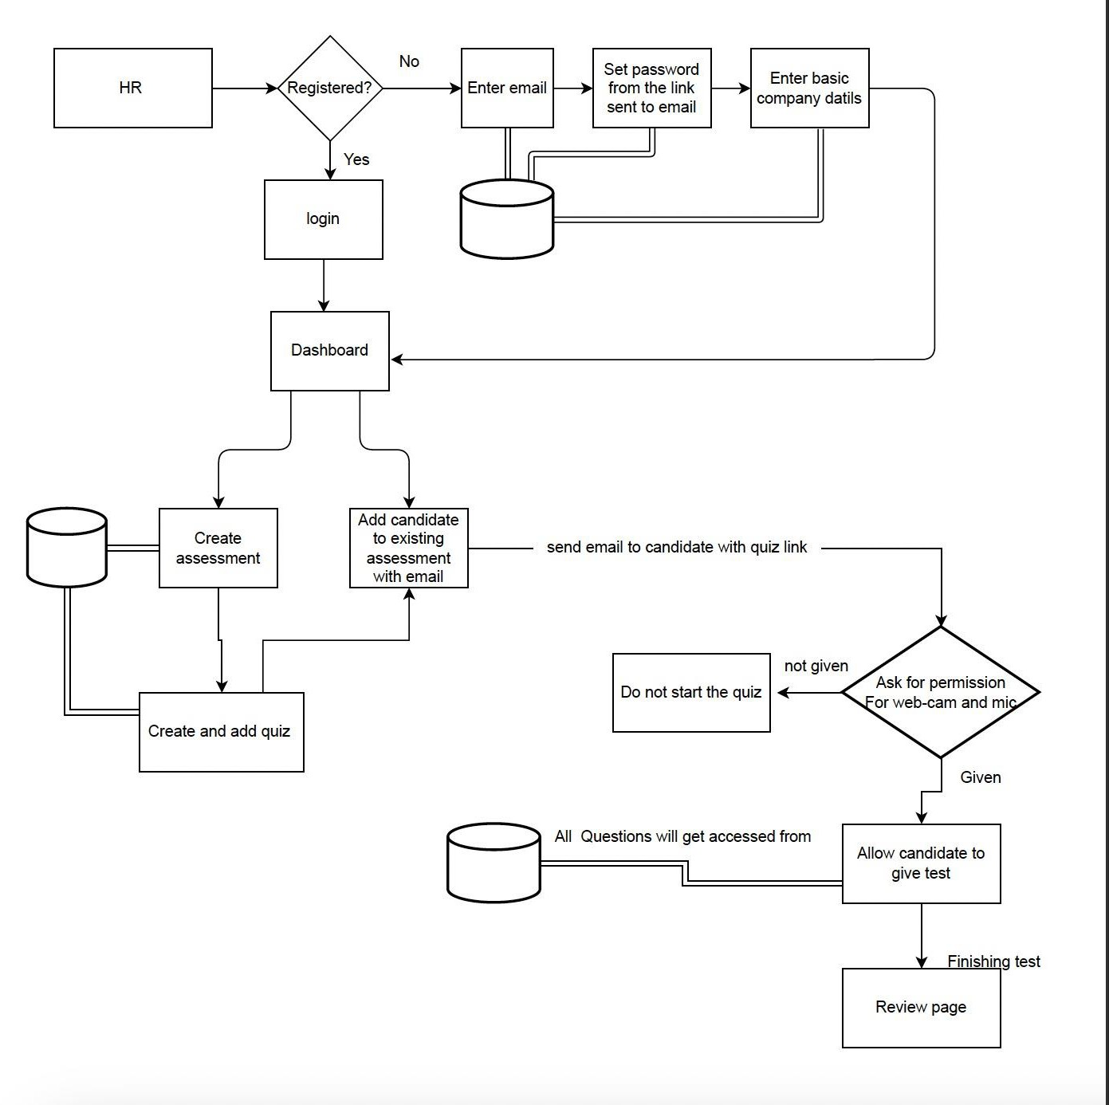

* 1. **Division of labor among team members**

I have taken care of all the front end i.e., preparing pages in React JS. Resolved issues with rendering elements and worked on the code editor. As ttechnologies used the in the project are totally new to me, I studied react first via YouTube and worked on the project. In this project, I learned how to send the payload to API. I have also created a few sample APIs in python to see whether the pages designed by me working properly or not. In this project, I was responsible for designing and fetching the values of questions posted in the database. Also, I have used Cloudinary and taken images every after 10 sec of live streaming and stored those images in Cloudinary. In addition to this, I have integrated the backend and frontend part I faced a lot of issues while integrating both sides.

Issues like ERROR CODE 404,401,500.

My Project partner took care of all the back-end parts. Creating APIs, sending emails, and handling tokens throughout the session.

# Technologies:

* + - In this project, we used
      1. React is a front-end JavaScript library. React is capable of making API calls (sending the request to the backend), which deal with the data. Also react is used by most companies now nowadays Instagram, Airbnb, discord, etc. so to learn and get hands-on experience during the course we decided to use React.
      2. We decided to use the python Flask framework at the backend to perform the get, put, post, and delete operations on data. We decided to use python because python is getting more popular day by day also there are many packages that are directly available in python such as m2Crypto. We used ‘Sha256’ Encryption to encrypt passwords and store them in a database. Additionally, having hands-on experience in python will give us chance to learn ML, Data Analytics, and AI in the future. Some companies using python are google, Facebook, etc.
      3. We decided to use MySql as a database because it is easy to use and highly efficient and secure. We can easily write and understand SQL queries.

# CHAPTER 3: INSTALLATION PROCESS

* + - * 1. **Build/Installation/launch Instruction**

Installation Process:

To clone the project from git use

git clone“ <https://github.com/chinmayn1/comp5130f2022.git>”

After cloning navigate to IWS1- project final directory

For react

For React modules there are two folders (react-backend and react front-end) we need to install nodes to run them.

You can check node is installed or not by ‘node-version’

If it’s installed, then open projects and type the command ‘npm update

After that use ‘npm start’.

If the node is installed, then install the node from <https://nodejs.org/en/download/>

After successful installation of the node perform steps 2 to 4

For python

For python we need to check whether python is installed or not by command ‘python –version’

If it is installed the type command ‘pip install -r requirements.txt’.

Type the command ‘venv\scripts\activate’.

After that type of ‘flask run’.

If python is not installed, then install it from <https://www.python.org/downloads/>

After installation of python perform steps 2 to 4

# Use of Software

In this project, there are total 2 Module

1. Recruiter
2. Candidate
   * Recruiter: -
3. The recruiter will first sign up for the web application, after which he or she will receive an email asking them to verify their email address and create a password. Upon login, the recruiter will get redirected to the dashboard which will provide the history of past assessments, if any.
4. A recruiter may build a new exam on the dashboard. In the assessment, the recruiter can design a quiz using a variety of tools, including coding, MCQ, MSQ, video recording, essay writing, etc.
5. After creating an assessment with questions and dedicated time, the recruiter has the option to add a candidate with a first name, last name, and email address. Upon successful addition email with a link to the assessment will be sent to the email entered while inviting the candidate. A recruiter can delete the candidate later.
   * Candidate: -
     1. The recruiter's email with the web link is the candidate's entrance point. When the candidate clicks on the link, he will get redirected to the assessment questions.
     2. Before starting to attempt the quiz web page requests the candidate's image and must be granted access to the camera.
     3. The front end will use the camera to capture the screen, and the candidate must submit their answers within the time limit set by the recruiter for each question.
     4. While taking the quiz, we ask that the candidate keep their webcam turned on so that we can take screenshots and not have to upload the entire streaming video.

# CHAPTER-4: Limitations

My project has the following limitations (list below)

* + - 1. Candidate and HR/ Recruiter cannot see the result of the exam.
      2. HR/ Recruiter cannot edit and delete the Assessment. They always need to create new always.
      3. HR can not backtrace while creating an assessment.
      4. If the candidate removes access given to the webcam and mic in between then also he can submit the test.

# CHAPTER-5: Future Work

In this project, we have some limitations we can work on those in the future, and also we can use bootstrap technology to make websites responsible for devices of different sizes.

# CHAPTER-6: References

1. [**https://bootcamp.uxdesign.cc/7-benefits-of-using-mysql-in-your-business-e587e326144f**](https://bootcamp.uxdesign.cc/7-benefits-of-using-mysql-in-your-business-e587e326144f)
2. [**https://reactjs.org/docs/getting-started.html**](https://reactjs.org/docs/getting-started.html)
3. [**https://stackoverflow.com/**](https://stackoverflow.com/)
4. [**https://github.com/manuarora700/react-code-editor**](https://github.com/manuarora700/react-code-editor)
5. [**https://www.npmjs.com/package/react-simple-code-editor**](https://www.npmjs.com/package/react-simple-code-editor)
6. [**https://www.w3schools.com/**](https://www.w3schools.com/)
7. [**https://www.javatpoint.com/reactjs-tutorial**](https://www.javatpoint.com/reactjs-tutorial)
8. [**https://www.youtube.com/playlist?list=PL7yh-TELLS1E6dNCzfQl-NG-KJP3C-4mc**](https://www.youtube.com/playlist?list=PL7yh-TELLS1E6dNCzfQl-NG-KJP3C-4mc)
9. [**https://www.youtube.com/playlist?list=PL7yh-TELLS1F3KytMVZRFO-xIo_S2_Jg1**](https://www.youtube.com/playlist?list=PL7yh-TELLS1F3KytMVZRFO-xIo_S2_Jg1)
10. [**https://www.youtube.com/playlist?list=PL7yh-TELLS1FuqLSjl5bgiQIEH25VEmIc**](https://www.youtube.com/playlist?list=PL7yh-TELLS1FuqLSjl5bgiQIEH25VEmIc)
11. [**https://www.youtube.com/playlist?list=PL7yh-TELLS1GNyuvPsFEqb7JVMEUTtuau**](https://www.youtube.com/playlist?list=PL7yh-TELLS1GNyuvPsFEqb7JVMEUTtuau)
12. [**https://www.youtube.com/watch?v=w7ejDZ8SWv8**](https://www.youtube.com/watch?v=w7ejDZ8SWv8)
13. **https://**[**www.youtube.com/watch?v=b9eMGE7QtTk**](http://www.youtube.com/watch?v=b9eMGE7QtTk)